PRIVACY POLICY AND ASSOCIATED PROCEDURES
NATIONAL INSTITUTE OF SCIENCE

RTO Code: 45258
CRICOS PROVIDER CODE: 04328K

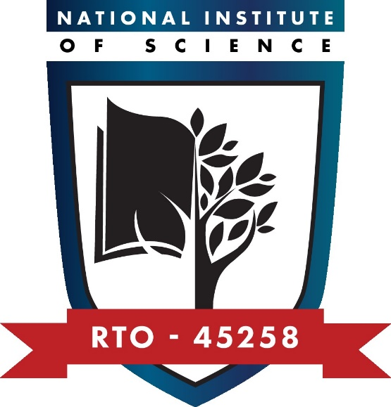
Privacy Policy and Associated Procedures
Purpose of the policy
This policy and associated procedures outline National Institute of Science’s approach to ensuring the privacy and confidentiality of all of its staff, students and relevant others.
This policy and associated procedures meet the requirements of information management of Standard 4.3 of the Outcome Standards for RTOs and Compliance Requirements (Section 1) regarding information management, as well as Standard 3 of the National Code of Practice for Providers of Education and Training to Overseas Students 2018, as well as the National VET Regulator (Data Provision Requirements) Instrument 2020 and National VET Data Policy.
Policy statements
Privacy legislation and principles
National Institute of Science has adopted the Australian Privacy Principles contained in the Privacy Act 1988.
Collection of personal information
National Institute of Science collects personal information only for the purposes of its business operations.
National Institute of Science also collects personal information about students undertaking nationally recognised training and discloses this information to the National Centre for Vocational Education Research Ltd (NCVER).
National Institute of Science provides information to staff and students about why their information is being collected and how it will be used, as well as their ability to access information held about them.
Both staff and students have the right to request that their personal information be changed.
A Privacy Notice is included in the Application for Enrolment Form and Offer Letter and Student Agreement.
Staff contracts refer to privacy rights and obligations.
All personal information is kept secure and confidential at all times.
All persons have the right to make a complaint or appeal in relation to privacy matters as per National Institute of Science’s Complaints and Appeals Policy and Procedures.
Sensitive information
National Institute of Science also collects sensitive information. Sensitive information is defined in the Privacy Act to include information or opinion about such things as an individual's racial or ethnic origin, political opinions, membership of a political association, religious or philosophical beliefs, membership of a trade union or other professional body, criminal record or health information.
Sensitive information will only be used by National Institute of Science:
- for the primary purpose for which it was obtained
- for a secondary purpose that is directly related to the primary purpose
- with an individual’s consent; or where required or authorised by law.
Procedures
1. Manage personal information
1.1 | Process all personal information according to the relevant procedures.
1.2 | Archive personal information according to the relevant procedures.
2. Provide access to records
2.1 | Review written requests for access to records.
2.2 | Arrange for the individual to view their personal information as requested.
2.3 | Update personal information according to any requests made.
2.4 | Keep all documentation relating to access to records.

Responsibilities
The RTO Manager is responsible for ensuring privacy at all times and consulting staff on WHS.
The Administration and Student Support Officer is responsible for processing all personal information and providing access to records as required.

Approvals and Document Control
This set of policies and procedures has been purchased under a licence agreement with RTO Works and has been reviewed and customised to suit National Institute of Science’s specific requirements.
Version number: | V2.1
Status: | Approved
Approved by: | CEO
Approval signature: | Khero Afzal
Approval date: | 12/09/2025
Review date: | Sep 2026

