HEALTH AND SAFETY POLICY AND ASSOCIATED PROCEDURES
NATIONAL INSTITUTE OF SCIENCE

RTO Code: 45258
CRICOS PROVIDER CODE: 04328K

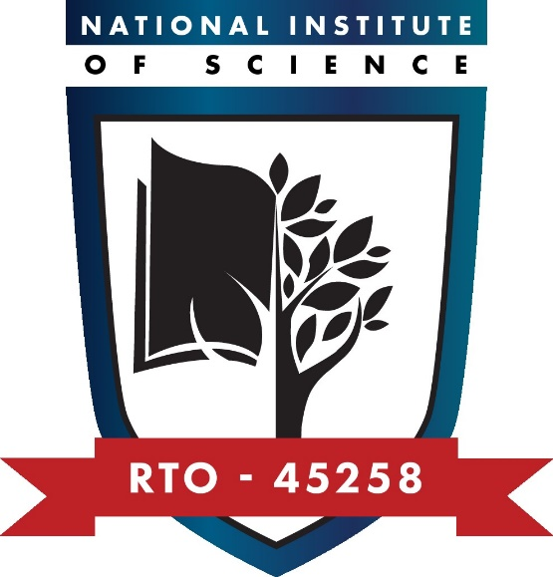
Health and Safety Policy and Associated Procedures
Purpose of the policy
This policy and associated procedures outline National Institute of Science’s approach to managing health and safety of all staff, students, contractors and visitors.
This policy and associated procedures meet the requirements of Standard 4.3 of the Outcome Standards for RTOs and compliance with other requirements in the Compliance Requirements, as well as Standard 6.9 of the National Code of Practice for Providers of Education and Training to Overseas Students 2018.
Policy statements
Compliance with legislation
National Institute of Science complies with the Work Health and Safety Act 2012 (TAS) and all other applicable Commonwealth and State legislation, regulations, codes of practice, and relevant advisory or best practice standards.
Organisation responsibility and commitment
National Institute of Science is committed to:
- providing a safe and healthy environment for all staff, students, contractors and visitors and others during their participation in activities with National Institute of Science
- implementing effective risk management systems that are relevant and suitable for the organisation’s scope of business
- promoting workplace health and safety at all times
- continuously improving performance in relation to health and safety
- encouraging active participation, cooperation and consultation with all staff and others in the promotion and development of measures to improve health and safety
- actively responding to, recording and investigating all incidents
- maintaining relevant policies, procedures, training, codes of conduct and systems to support and communicate effective health and safety practices throughout the organisation
- routinely conducting checks of the work environment to assess risks, identify hazards and identify areas for improvement
- taking immediate response to reduce the risk of identified workplace hazards
- providing appropriate induction, training, information and updates to staff, students and others on a regular basis about workplace health and safety.

Staff responsibility
All staff including managers have a responsibility to work safely, take all reasonable care for their own health and safety and always consider the health and safety of others who may be affected by their actions.
When staff are undertaking work from home or at an off-site location, the staff member is responsible for ensuring the environment they enter into is free from risk and occupational health and safety hazards.
Health and safety consultation and communication
Health and safety consultation and communication will be carried out as follows:
- Team meetings (where work health and safety is always an agenda item).
- One off meetings to discuss health and safety issues arising.
- Briefing sessions on new health and safety requirements/information.
Records of all meetings will be kept and action plans to address issues will be drawn up as required.
Follow up of actions to be taken will occur through regular team meetings.
Reporting
All staff, and others are required to report any identified workplace hazards and associated risks as soon as they become aware of them.
All staff, and others are required to report any incident that causes harm to a person during their participation in work and/or training activities with National Institute of Science.
Record keeping
Appropriate records of the organisation’s risk management strategy, workplace hazards and workplace injuries will be accurately maintained at all times.
Procedures
1. Manage work health and safety management system
1.1 | Identify and action WHS issues on an ongoing basis.
1.2 | Consult with staff on WHS issues.
1.3 | Action WHS issues as required.
1.4 | Provide training to staff on WHS issues as required.
1.5 | Ensure all visitors to National Institute of Science sign in and out on the Visitor Register.
1.6 | Keep all health and safety records.
2. Conduct workplace inspections
2.1 | Inspect the workplace for hazards and risks.
2.2 | Control hazards and risks using selected control methods or report hazards and risks.
3. Respond to incidents
3.1 | Report any incidents using the Workplace Incident Form.
3.2 | Submit Workplace Incident Form to relevant Manager.
3.3 | In the case of an injury, the first person in attendance must contact the First Aid Officer or emergency services in the case of a serious injury.

Responsibilities
The CEO is responsible for overall health and safety management.
The RTO Manager is responsible for ensuring health and safety at all times and consulting staff on WHS.
All staff are responsible for identifying and reporting health and safety issues and incidents and applying safe work practices at all times.

Approvals and Document Control
This set of policies and procedures has been purchased under a licence agreement with RTO Works and has been reviewed and customised to suit National Institute of Science’s specific requirements.
Version number: | V2.1
Status: | Approved
Approved by: | CEO
Approval signature: | Khero Afzal
Approval date: | 12/09/2025
Review date: | Sep 2026

