DEFERRAL, SUSPENSION AND CANCELLATION POLICY AND ASSOCIATED PROCEDURES
NATIONAL INSTITUTE OF SCIENCE

RTO Code: 45258
CRICOS PROVIDER CODE: 04328K

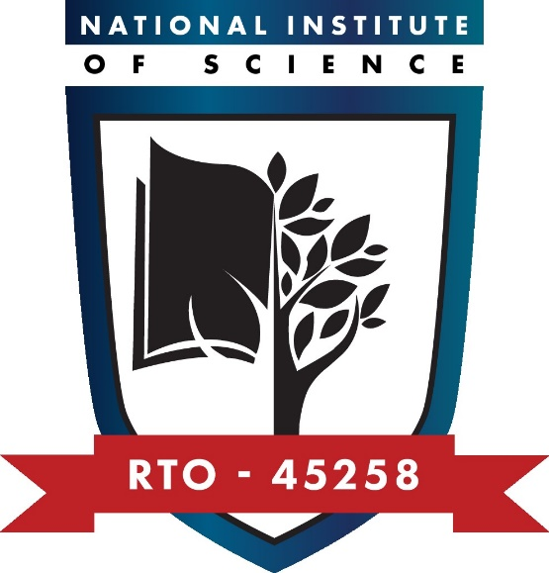
Deferral, Suspension and Cancellation Policy and Associated Procedures
Purpose of the policy
This policy and associated procedures outline National Institute of Science’s approach to managing the enrolment of international students, specifically deferrals, suspensions and cancellations, and ensuring all required information about enrolments is entered into PRISMS.
This policy and associated procedures meet the requirements of Standard 9 of the National Code of Practice for Providers of Education and Training to Overseas Students 2018.
Policy statements
Student-initiated deferral or suspension or cancellation
All students can defer or suspend their studies. National Institute of Science allows the deferral or suspension of studies where evidence of compassionate or compelling circumstances can be provided by students. Evidence of compassionate or compelling circumstances will be considered as part of the decision about suspension or cancellation.
Deferrals and leave of absences will be approved for up to 12 months. However, following this the student’s enrolment will be cancelled.
Domestic students may withdraw from their course at any time. Refunds will be calculated in line with National Institute of Science’s Fees and Refunds Policy and Associated Procedures.
International students may also withdraw from their course at any time. Where an international student has not already completed six months of their principal course of study, their application will be assessed as per National Institute of Science’s Course Transfer Policy and Associated Procedures. International students are entitled to a refund as per National Institute of Science’s Fees and Refunds Policy and Associated Procedures.
Provider-initiated suspension or cancellation
A student’s enrolment may be cancelled or suspended by National Institute of Science in a range of circumstances:
- misbehaviour (i.e., not abiding by the Student Code of Conduct as outlined in this Handbook)
- not paying course fees
- not meeting course progress and attendance requirements.
Not paying course fees and not meeting course progress and attendance requirements will be managed as documented in the Fees and Refunds and Course Progress and Attendance Policy and Associated Procedures.
Any student who breaches the Code of Conduct as applicable to expected behaviour will be immediately suspended. Their case will be considered during the period of suspension and the student may then be reinstated or have their enrolment cancelled.
Where any of the above circumstances apply, the student will be contacted in writing with regard to the intended suspension or cancellation and the reasons for this.
Students will be able to access the Complaints and Appeals Policy and Procedure to appeal the decision within 20 working days of receipt of the decision.
Domestic students’ enrolment will not be cancelled until the internal appeal process is complete, unless their health and wellbeing or that of others could be at risk.
International students will not be reported until the internal appeal process is complete, unless their health and wellbeing or that of others could be at risk.
International students are advised to contact the DHA to seek advice on their student visa.
Procedures
1. Process deferrals
1.1 |  | Provide Deferral Application Form to students who request deferral.
1.2 |  | Assess Deferral Application Form and supporting evidence to confirm that compassionate or compelling circumstances exist.
1.3 |  | Complete assessment and advise student of outcome within 5 working days of receipt.
1.4 |  | Where the application for deferral is approved, advise the student in writing of such.
1.5 |  | Where the application is not approved, advise the student in writing of such indicating the reasons, any refunds due and advising them of their right to appeal the decision within 20 working days.
1.6 |  | For approved deferrals (domestic students):  - issue the updated Offer Letter and Student Agreement to the student.  - update student records on the SMS
1.7 |  | For approved deferrals (international students):  - issue the updated Offer Letter and Student Agreement to the student  - report a student course variation (SCV) on PRISMS within 31 days of the request being approved and according to the instructions provided in the PRISMS user guide.  - issue the updated CoE to the student  - update student records on the SMS
2. Process student-initiated suspension of enrolment
2.1 |  | Provide Suspension Application Form to students who request suspension.
2.2 |  | Assess Request for Suspension Form and supporting evidence to confirm that compassionate or compelling circumstances exist.
2.3 |  | Complete assessment and advise student of outcome within 5 working days of receipt.
2.4 |  | Where the application for suspension is approved, advise the student in writing of such.
2.5 |  | Where the application is not approved, advise the student in writing of such indicating the reasons, any refunds due and advising them of their right to appeal the decision within 20 working days.
2.6 |  | For approved suspensions (domestic students), update student records on the SMS
2.7 |  | For approved suspensions (international students):  - report a student course variation (SCV) on PRISMS within 31 days of the request being approved and according to the instructions provided in the PRISMS user guide  - issue the updated CoE to the student.  - update student records on the SMS
 | 3. Process student-initiated cancellation of enrolment
 | 3.1 |  | Provide Withdrawal Application Form to students who request to withdraw.  For international students only: ensure that this is only provided to students who have completed more than six months of their principal course of study. Otherwise, the student will need to complete a Release Application Form.
 | 3.2 |  | Review Withdrawal Application Form to ensure all details have been provided.
 | 3.3 |  | Notify the student in writing within 5 working days of receipt of application of confirmation of their withdrawal and any refund as application as per National Institute of Science’s Fees and Refunds Policy and Associated Procedures.
 | 3.4 |  | Record the student’s withdrawal on the SMS.
 | 3.5 |  | For international students only: Report Student Notified Cessation of Studies on PRISMS within 31 days of the withdrawal being processed and according to the instructions provided in the PRISMS user guide.
 | 4. Manage provider-initiated cancellation of enrolment
 | 4.1 |  | Where a student misbehaves (i.e., they contravene the Student Code of Conduct), immediately investigate the incident.
 | 4.2 |  | Where the incident is considered serious to warrant further investigation, inform the student in writing of the suspension including the reasons why and the dates from which the suspension applies, as well as their right to appeal the decision within 20 working days of receiving the notice.
 | 4.3 |  | Further investigate the student’s misbehaviour.
 | 4.4 |  | Inform any other relevant agencies of the issue concerning the student such as in the case of fraud or violence.
 | 4.5 |  | Where the investigation deems the student can be reinstated, advise the student in writing that their suspension is lifted.
 | 4.6 |  | Where the investigation deems the student’s behaviour as so serious that they cannot be reinstated, advise the student in writing of the cancellation of their enrolment, including the reasons for the decision.
 | 4.7 |  | Record the student’s withdrawal on the SMS.
 | 4.8 |  | For international students only: report provider decision to cease enrolment for disciplinary reasons on PRISMS within 31 days of the withdrawal being processed and according to the instructions provided in the PRISMS user guide.

Responsibilities
The RTO Manager is responsible for:
- investigating student misbehaviour
- making decisions regarding student misbehaviour and cancellation
- reporting decisions on PRISMS regarding provider-initiated suspension and cancellation.
The Administration and Student Support Officer is responsible for:
- assessing deferral requests and reporting deferrals on PRISMS
- assessing suspension requests and reporting suspensions on PRISMS
- processing withdrawals.

Approvals and Document Control
This set of policies and procedures has been purchased under a licence agreement with RTO Works and has been reviewed and customised to suit National Institute of Science’s specific requirements.
Version number: | V2.1
Status: | Approved
Approved by: | CEO
Approval signature: | Khero Afzal
Approval date: | 12/09/2025
Review date: | Sep 2026

