COURSE TRANSFER POLICY AND ASSOCIATED PROCEDURES
NATIONAL INSTITUTE OF SCIENCE

RTO Code: 45258
CRICOS PROVIDER CODE: 04328K

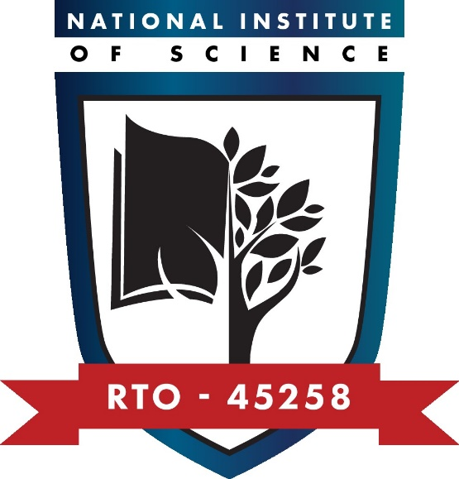
Course Transfer Policy and Associated Procedures
Purpose of the policy
This policy and associated procedures ensure that National Institute of Science does not knowingly enrol an international student who wishes to transfer from another registered provider prior to the international student completing six months of their principal course.
This policy and associated procedures meet the requirements of Standard 7 of the National Code of Practice for Providers of Education and Training to Overseas Students 2018.
Policy statements
Overview
National Institute of Science will not knowingly enrol an international student who wishes to transfer from another registered provider’s course prior to the student completing six months of his or her principal course except in the case of any of the following circumstances:
- the releasing registered provider or the course in which the student is enrolled has ceased to be registered;
- the releasing registered provider has had a sanction imposed on its registration by ASQA that prevents the student from continuing their principal course at that registered provider;
- the releasing registered provider has agreed to the overseas student’s release and recorded the date of effect and reason for release in PRISMS;
- any government sponsor of the student considers the change to be in the student’s best interest and has provided written support for that change.
Assessing course transfer requests to other registered providers and circumstances where the transfer request will be granted
International students who wish to transfer to another registered provider prior to completing six months of their principal course must complete an Application for Release Form and attach a valid offer from another registered provider.
The outcome of the assessment will be provided within 10 working days of receipt of the form and valid enrolment offer. Where the request is granted, a Letter of Release will be provided. The Release Letter will advise students to contact the DHA to seek advice on whether a new student visa is required. Refunds will be in accordance with National Institute of Science’s Fees and Refunds Policy and Procedure.
The transfer request will be granted where any of the following circumstances apply:
- The student will be reported because they are unable to achieve satisfactory course progress at the level they are studying, even after engaging with National Institute of Science’s intervention strategy to assist the overseas student in accordance with Standard 8 (overseas student visa requirements).
- There is evidence of compassionate or compelling circumstances.
- National Institute of Science fails to deliver the course as outlined in the Offer Letter and Student Agreement.
- There is evidence that the student’s reasonable expectations about their current course are not being met.
- There is evidence that the student was misled by National Institute of Science or an education or migration agent regarding National Institute of Science or its course and the course is therefore unsuitable to their needs and/or study objectives.
- An appeal (internal or external) on another matter results in a decision or recommendation to release the student.
Circumstances where the transfer request will not be granted
A transfer request will not be granted where any of the following circumstances apply:
- There are no legitimate compassionate or compelling circumstances.
- The student has not paid their fees.
- The transfer may jeopardise the student’s progression through a package of courses.
- The student has recently started studying the course and the full range of support services are yet to be provided or offered to the student.
- The student is trying to avoid being reported to DHA for failure to meet the provider's attendance or academic progress requirements.
Where the request is not granted, the reasons for non-grant of the request will be communicated in writing. The letter will advise the student that they may access the Complaints and Appeals Policy and Procedure to appeal the decision within 20 working days of receipt of the decision.
National Institute of Science will not finalise the student’s refusal status in PRISMS until the appeal process is complete and either finds in favour of National Institute of Science or until the 20-working day period in which the student can access the complaints and appeals process has passed.
Internal transfer
National Institute of Science allows students to transfer to other courses offered by National Institute of Science in any of the following circumstances:
- The course better meets the study capabilities of the student; and/or
- the course better meets the long-term goals of the student, whether these relate to future work, education or personal aspirations; and/or
- the student provides evidence that their reasonable expectations about the current course are not being met.
A transfer to another course within National Institute of Science will not be granted in any of the following circumstances:
- The transfer may jeopardise the student’s progression through a package of courses.
- The student has recently started studying the course and the full range of support services are yet to be provided or offered to the student.
- The student is trying to avoid being reported to DHA for failure to meet the provider's attendance or academic progress requirements.
International students who wish to transfer to another course should complete the Internal Course Transfer Application Form.
The outcome of the student’s application for internal course transfer will be provided in writing within 10 working days of receipt of the form. Where the application is not granted, reasons for such will be provided.
Record keeping
National Institute of Science will maintain all records of requests for course transfer and documentation associated with the assessment and decision regarding the request. Records will be maintained for a minimum of 2 years following the student’s completion or withdrawal from their course.
Procedures
1. Manage transfers in
1.1 | On receipt of an application from a student that has not completed six months of their principal course of study, check the student on PRISMS following the information about Standard 7 in the PRISMS user guide and to ensure they have been released from the previous provider.
1.2 | If the check confirms that the student has been released follow the usual procedures for enrolling a student.
1.3 | If the check confirms that the student has not been released, advise the student in writing and within 3 working days of receipt of their application that it has not been approved.
1.4 | File all documentation.
2. Manage transfers out
2.1 | Where a student wishes to transfer to another provider before having completed six months of their principal course of study with National Institute of Science, provide students with Application for Release form.
2.2 | Acknowledge receipt of completed forms within 3 working days of receipt.
2.3 | Review and assess the application provided within 10 working days of receipt. For an application to be approved, supporting documentation must demonstrate that compassionate and compelling circumstances exist.
2.4 | Advise the student in writing of the outcome of their application, including a Letter of Release where the application is approved. If it is not approved, provide the reasons and advise the student of their right to access the complaints and appeals process.
2.5 | Record approved releases on PRISMS following the information about Standard 7 in the PRISMS user guide.
2.6 | Record refusals of release on PRISMS following the information about Standard 7 in the PRISMS user guide.
2.7 | File all documentation and keep for a minimum of 2 years, after the overseas student ceases to be an accepted student.
3. Manage internal course transfers
3.1 | Where a student wishes to transfer to another course within National Institute of Science, provide students with Internal Course Transfer Application Form.
3.2 | Acknowledge receipt of completed forms within 3 working days of receipt.
3.3 | Review and assess the application provided within 10 working days of receipt. For an application to be approved, supporting documentation must demonstrate that there are appropriate reasons for transferring.
3.4 | Advise the student in writing of the outcome of their application, including a new Offer Letter and Student Agreement where the application is approved. If it is not approved, provide the reasons and advise the student of their right to access the complaints and appeals process.
3.5 | Advise the student in writing of any refunds due relevant to their existing course.
3.6 | Record student course variation on PRISMS following the information on student course variation in the PRISMS user guide.
3.7 | Record refusals of release on PRISMS following the information about Standard 7 in the PRISMS user guide.

Responsibilities
The RTO Manager is responsible for:
- managing transfers in and out
- managing internal course transfers.
The Administration and Student Support Officer is responsible for:
- filing course transfer documentation.
Approvals and Document Control
This set of policies and procedures has been purchased under a licence agreement with RTO Works and has been reviewed and customised to suit National Institute of Science’s specific requirements.
Version number: | V1.1
Status: | Approved
Approved by: | CEO
Approval signature: | Khero Afzal
Approval date: | 12/09/2025
Review date: | Sep 2026

